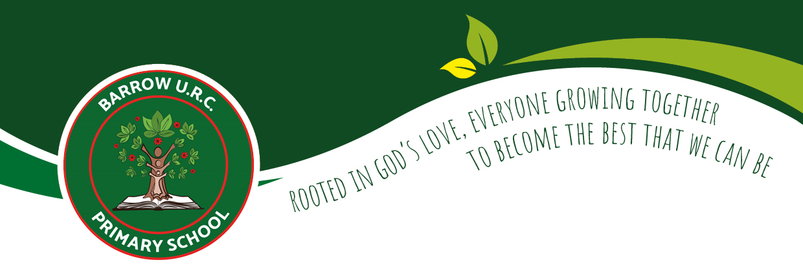

Maths Curriculum Overview
2024/25
Subject Leader: Mr Briggs

Intent, Implementation
and Impact

Our Vision

Rooted in God’s love, we will grow and learn together through the delivery of an enriched and creative curriculum. We are passionately committed to developing happy, well-rounded children who can reach their full potential with the skills, knowledge, and experiences to achieve their dreams. Our Curriculum drivers help to drive and shape our curriculum and are incorporated across all subjects and themes. Our Drivers are:
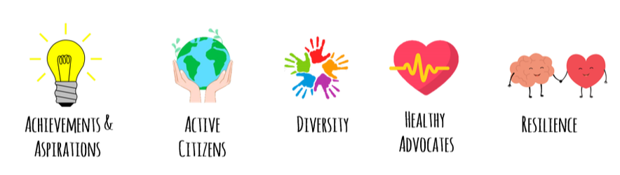

Intent

At Barrow URC Primary School, our aim is for every child to develop a sound understanding of maths, equipping them with the skills of calculation, reasoning and problem solving that they need in life beyond school; to make rich connections across the different areas of maths and use their knowledge across other subjects, realising the importance of maths in the wider world.

Implementation

We will use the following approaches in our teaching of mathematics:
- We teach maths daily (1 hour) throughout the year.
- Every class from EYFS to Y6 follows the White Rose scheme of learning which is based on the National Curriculum. Lessons may be personalised to address the individual needs and requirements for a class but coverage is maintained.
- The SoL is supported through implementations of extra resources. That are in line with White Rose
- Differentiation is achieved by emphasising deep knowledge and through individual support and intervention. It is seen through the concrete resources used, and/or the reliance on the representations and structures within a lesson to help embed a mathematical concept.
- All children are expected to be exposed to age related expectations and staff allow the time to plug gaps children may have in a particular area of mathematics.
- Staff understand what age-related expectations and mastery looks like for each objective and plan for how their children will get there. In order to meet the needs of all pupils, children working at a greater depth of understanding within an area of mathematics have ‘going deeper’ opportunities.
- Regular and ongoing formative assessment informs teaching, as well as intervention, to support and enable the success of each child.
- Daily basic skills sessions recap and rehearse key skills to aid retention and support fluency (standalone arithmetic lessons)
- The use of Times Table Rock Stars to support with times table knowledge and ensuring pupils are ready for the times table check.
- Create opportunities for the children to use their knowledge and understand how it will be used outside of school.

Impact

We will assess the impact of the curriculum by:
- Through discussion and feedback, children talk enthusiastically about their maths lessons and speak about how they love learning about maths. They can articulate the context in which maths is being taught and relate this to real life purposes.
- Children show confidence and believe they can learn about a new maths area and apply the knowledge and skills they already have.
- Children demonstrate quick recall of facts and procedures. This includes the recollection of the times tables.
- At the end of each year we expect the children to have achieved Age Related Expectations (ARE) for their year group. Some children will have progressed further and achieved greater depth (GD). Children who have gaps in their knowledge receive appropriate support and intervention.
- Pupils using the mathematical language to explain their ideas, and can independently apply the concept to new problems in unfamiliar situations.

Whole School Programme of Study:
Maths

Maths – Whole School Programme of Study (2023/24)

Maths | Autumn 1 | Autumn 2 | Spring 1 | Spring 2 | Summer 1 | Summer 2
EYFS | White Rose Maths:  Getting to Know you!  Just like me. | White Rose Maths:  It’s 1 2 3  Light and Dark | White Rose Maths:  Alive in.  5 Growing 6, 7, 8 | White Rose Maths:  Building 9, 10  Consolidation | White Rose Maths:  To 20 and beyond  First, then and now | White Rose Maths:  Find my pattern  On the move
Year 1 | White Rose Maths:  Number: Place Value  Number: Addition and Subtraction | White Rose Maths:  Number: Addition and Subtraction  Geometry: Shape | White Rose Maths:  Measurement: Money  Number: Multiplication & division | White Rose Maths:  Measurement: Length & height  Measurement: Mass, capacity and temperature | White Rose Maths:  Number: Fractions  Measurement: Time | White Rose Maths:  Statistics  Geometry: Position & direction
Year 2 | White Rose Maths:  Number: Place Value  Number: Addition and Subtraction | White Rose Maths:  Number: Addition and Subtraction  Geometry: Shape | White Rose Maths:  Measurement: Money  Number: Multiplication & division | White Rose Maths:  Measurement: Length & height  Measurement: Mass, capacity and temperature | White Rose Maths:  Number: Fractions  Measurement: Time | White Rose Maths:  Statistics  Geometry: Position & direction
Year 3 | White Rose Maths:  Number: Place Value  Number: Addition and Subtraction | White Rose Maths:  Number: Addition and Subtraction  Number: Multiplication and Division | White Rose Maths:  Number: Multiplication and Division  Measurement: Length and Perimeter | White Rose Maths:  Number: Fractions  Measurement: Mass and capacity | White Rose Maths:  Number: Fractions Measurement: Money | Measurement: Money  Geometry: Properties of Shape  Statistics
Year 4 | White Rose Maths:  Number: Place Value  Number: Addition and Subtraction | White Rose Maths:  Measurement: Area  Number: Multiplication and Division | White Rose Maths:  Number: Multiplication and Division Measurement: Length and Perimeter | White Rose Maths:  Number: Fractions  Number: Decimals | White Rose Maths:  Number: Decimals Measurement: Money  Statistics  Measurement: Time  Consolidation | White Rose Maths:  Geometry: Properties of shape  Statistics  Geometry: Position & direction
Year 5 | White Rose Maths:  Number: Place Value  Number: Addition and Subtraction | White Rose Maths:  Number: Multiplication and Division  Number: Fractions A | White Rose Maths:  Number: Multiplication and Division  Number: Fractions B  Number: Decimals and Percentages | White Rose Maths:  Measurement: Perimeter and area  Statistics | White Rose Maths:  Geometry: Properties of shape  Geometry: Position and direction  Numbers: Decimals | White Rose Maths:  Measurement: Volume  Measurement: Converting units
Year 6 | White Rose Maths:  Number: Place Value  Number: Addition, Subtraction, Multiplication and Division | White Rose Maths:  Number: Fractions A  Number: Fractions B  Measurement: Converting Units | White Rose Maths:  Number: Ratio  Number: Algebra  Number: Decimals, | White Rose Maths:  Number: Percentages  Measurement: Perimeter, Area and Volume  Statistics | White Rose Maths:  Geometry: Properties of shape  Geometry: Position and direction | White Rose Maths:  Consolidation Problem solving and reasoning  Themed maths projects

EYFS

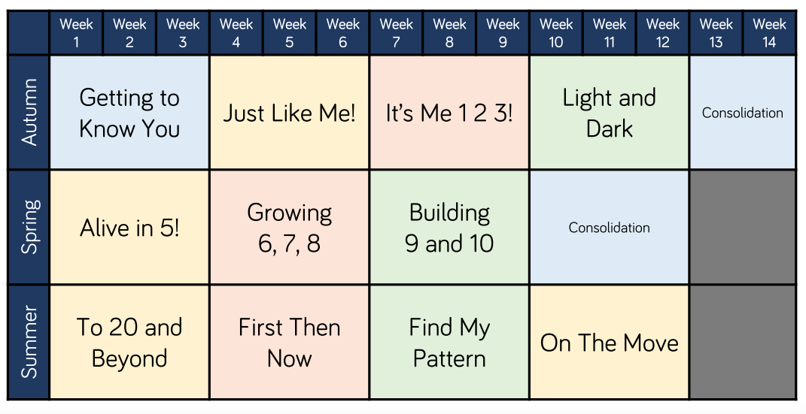

Year 1

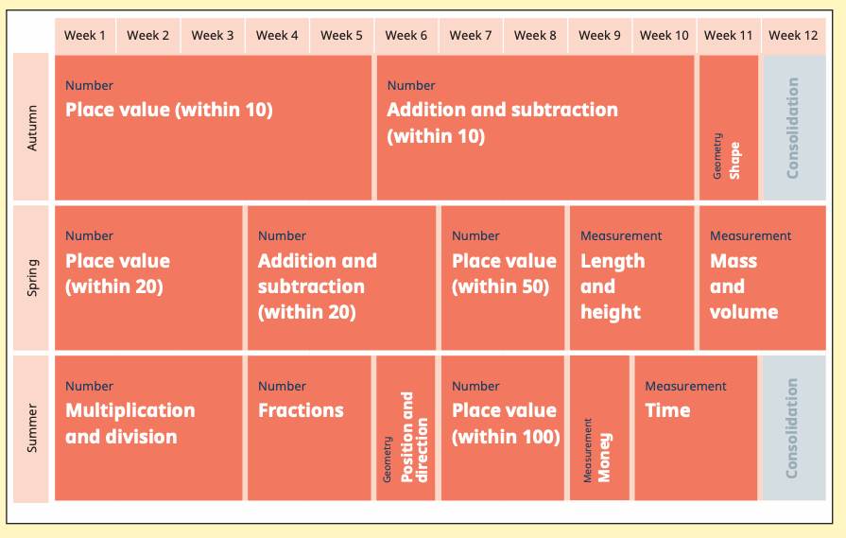
Year 2

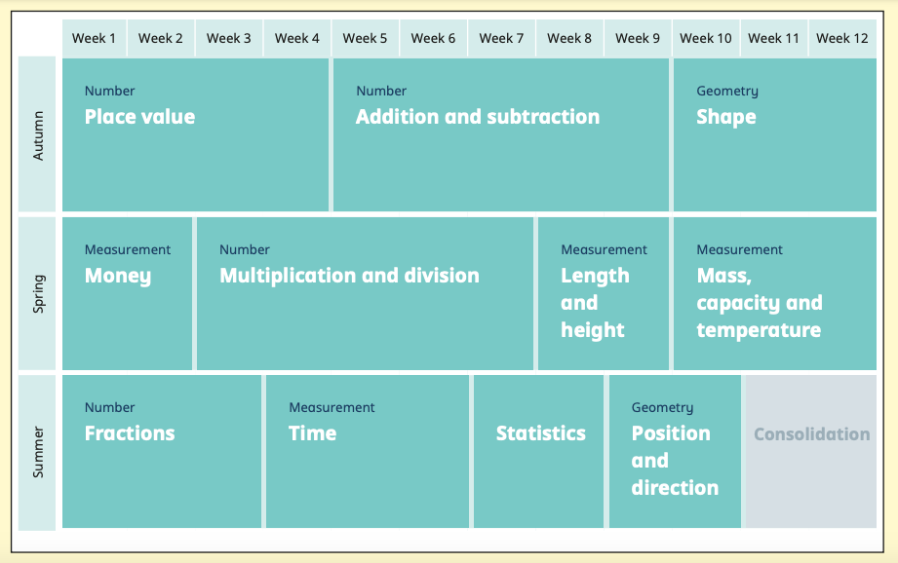
Year 3

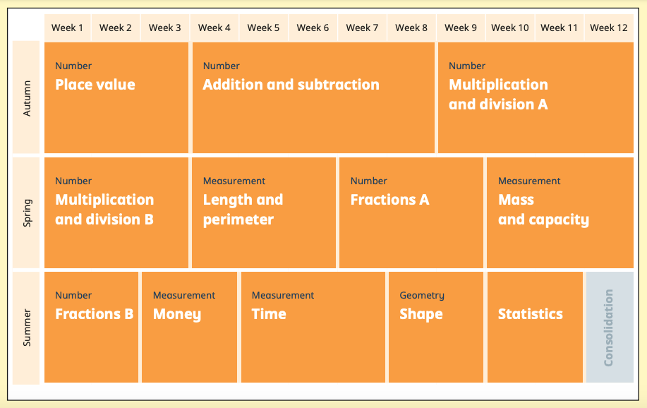
Year 4

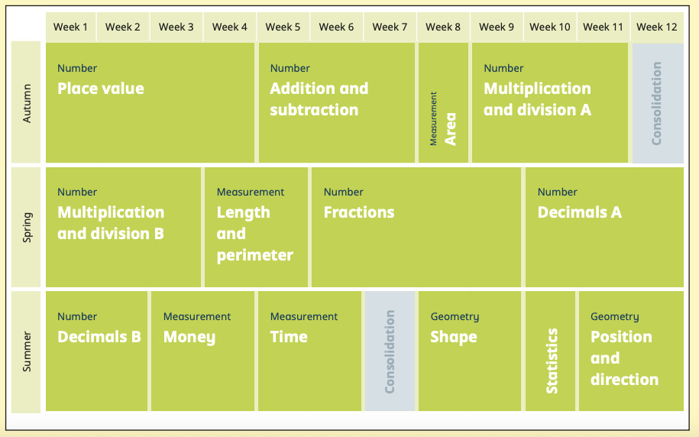
Year 5

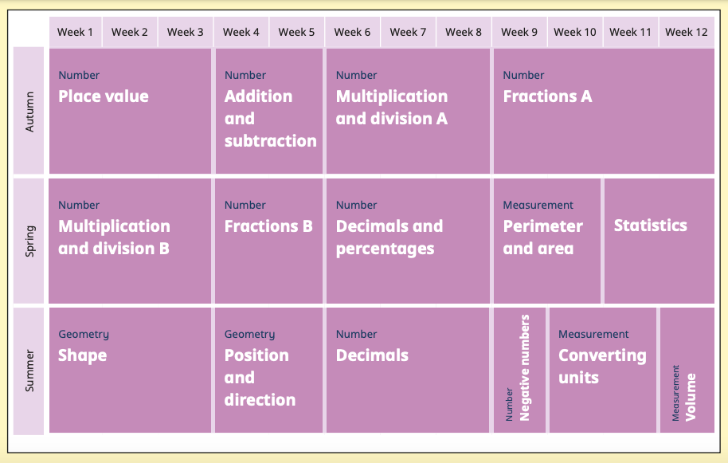

Year 6

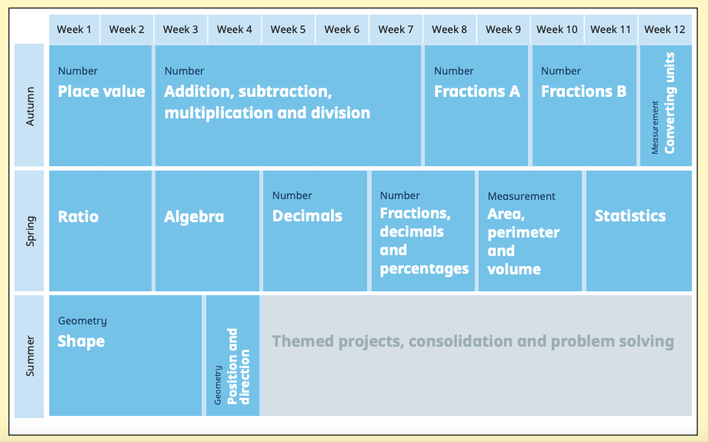

Maths in EYFS

In the EYFS, maths is introduced to the children through a play-based and hands-on approach. Maths is integrated throughout the learning environment, daily routines and through play. Adult led activities introduce children to the curriculum using concrete and abstract resources that will facilitate mathematical exploration, as well as introduce the children to key vocabulary. This is enhanced through continuous provision, where children have the opportunities to develop and build upon their mathematical knowledge and explore the different areas of the Maths curriculum through a supportive environment and play. During the reception year, the focus is on building a strong mathematical foundation in concepts and skills, promoting curiosity, problem solving and a positive attitude towards maths.
Maths and SEND Provision

The Maths curriculum accommodates and challenges pupils of all abilities and address a range of learning needs. Teachers of maths will consider any additional needs of SEND pupils and will implement any relevant targets and support strategies as outlined on pupils’ Individual Education Plans. Where necessary, we will provide specialist equipment, adapt room layouts, utilise adult support and allow additional time for tasks, according to the needs of our pupils.

Maths and identifying the more able learner
At Barrow, a “more able mathematician” often shows mathematical ability through quality reasoning and problem-solving rather than just complexity and high levels of mathematical reasoning that can be shown in a variety of ways including orally or in writing. These students approach challenging tasks with enjoyment and have the ability to use a range of different strategies to progress through the questions e.g. working backing backwards and teaching the teacher.

• Work systematically and accurately
• Be more analytical
• Think logically and see mathematical relationships
• Make connections between mathematical concepts they have learned
• Identify patterns easily
• Apply their knowledge to new or unfamiliar contexts
• Communicate their reasoning and justify their methods
• Ask questions that show clear understanding of, and curiosity about, mathematics
• Take a creative approach to solving mathematical problems including written problems
• Understand and acquire different approaches to problems, not relying on one strategy
• Sustain their concentration throughout longer tasks and persist in seeking solutions
• Be more adept at posing their own questions and pursuing lines of inquiry
Maths and provision for the more able.

Maths and Provision for the more able learner.
At Barrow, we ensure that those children who display characteristics of a more able learner in mathematics are provided with opportunities that regularly stretch and challenge them to a deeper level. Some ways that we do this are:

- Avoiding extensive and unnecessary practice of something which has been learnt
- Opportunities to hypothesise and predict what comes next.
- Provide answers for problems and ask them to “work backwards”
- Encourage pupils to find a number of different ways of solving problems.
- Provide more open ended tasks where pupils are encouraged to find multiple solutions
- Create an investigative approach rather than a focus on getting the right answers.

Knowledge and Skills Progression
Maths

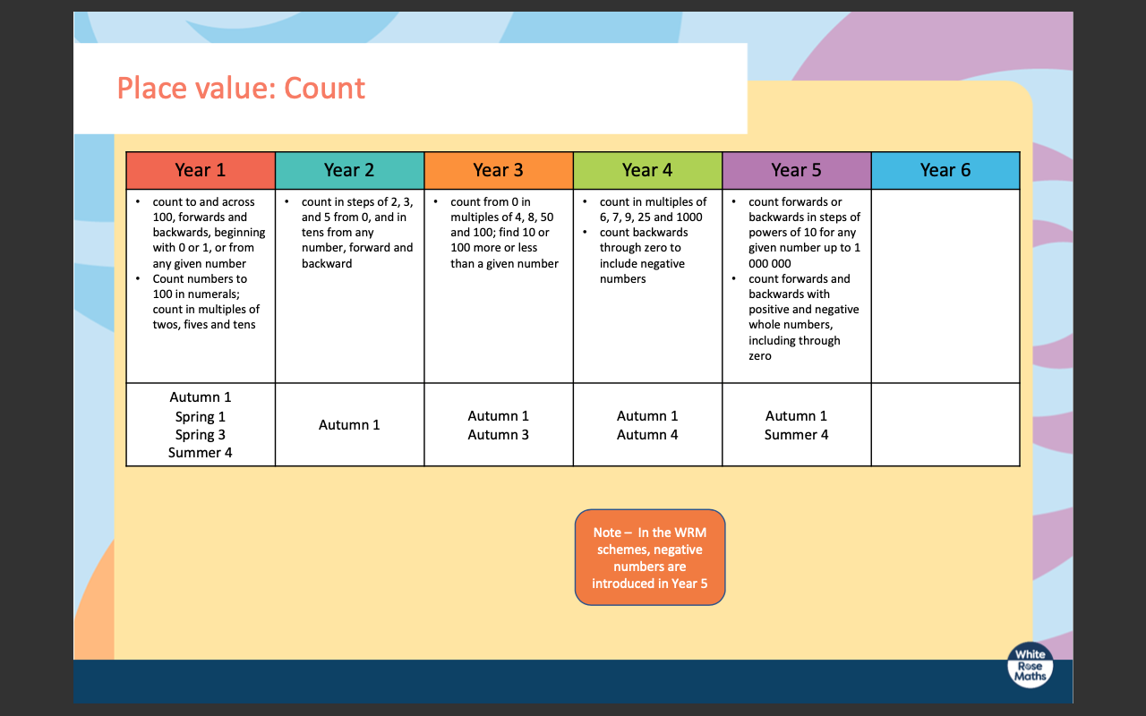
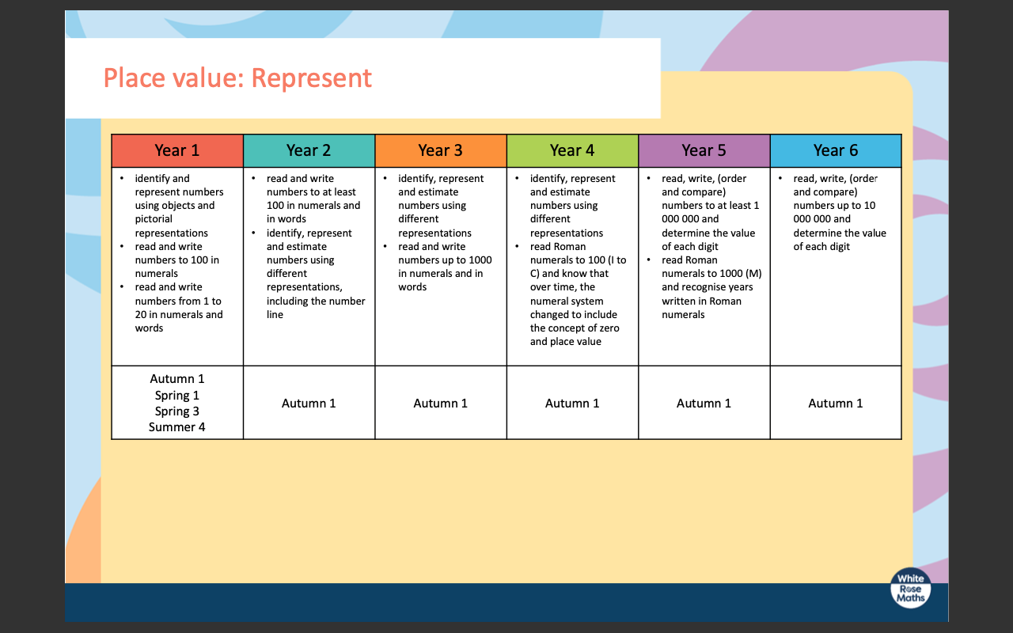
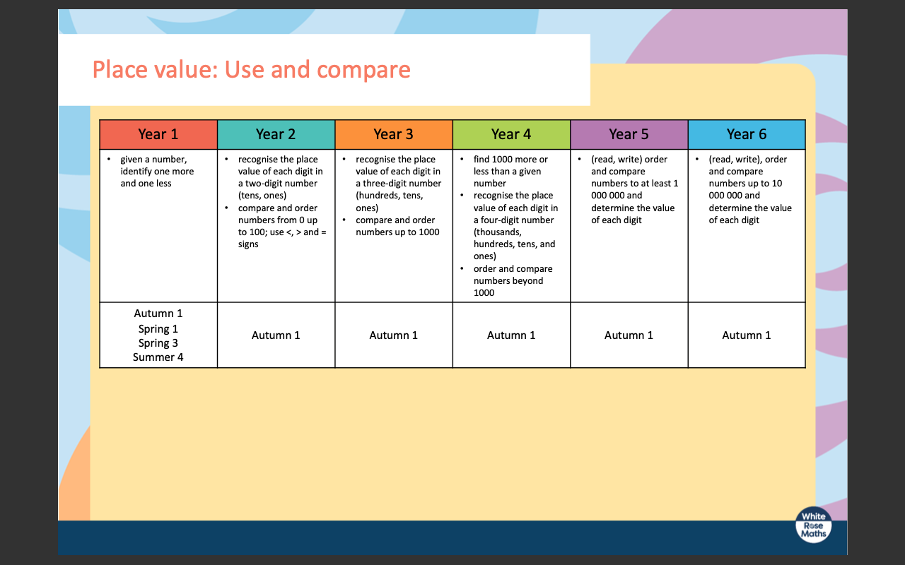
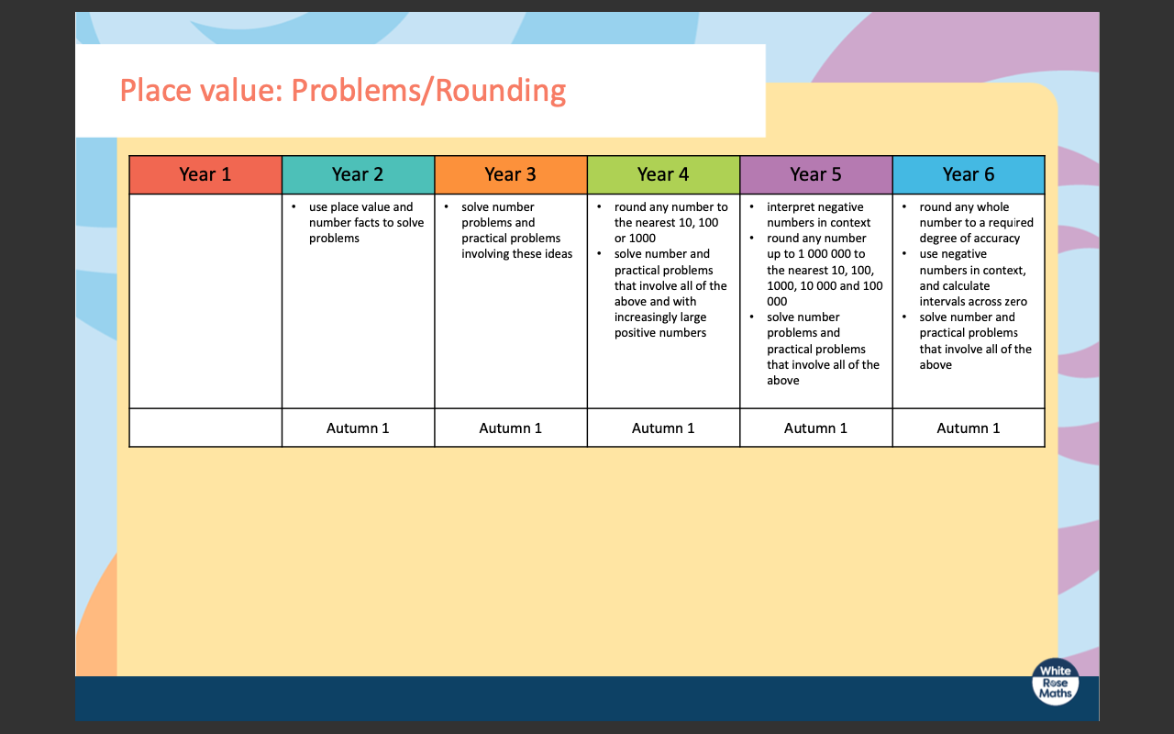
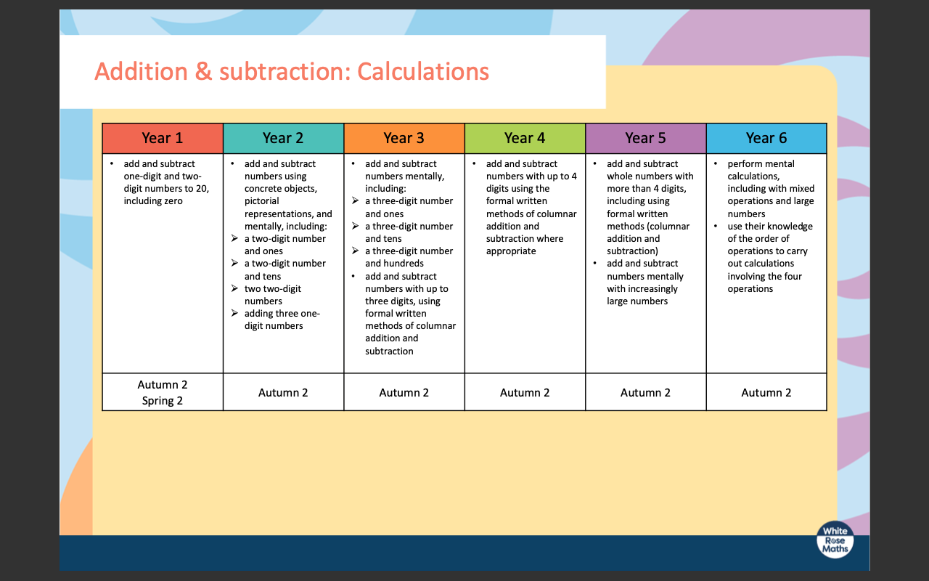
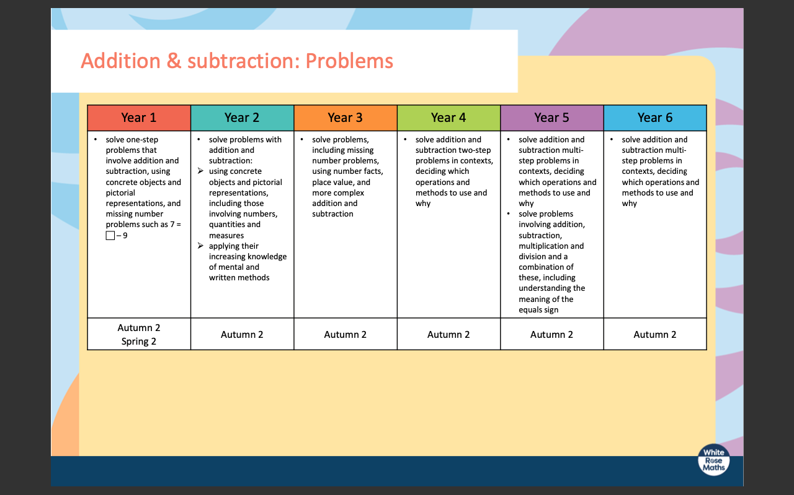
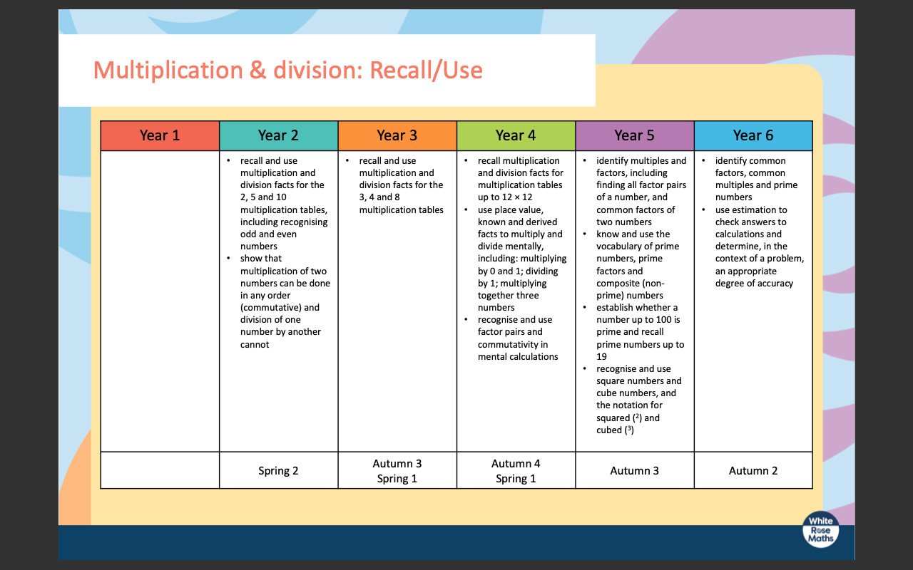
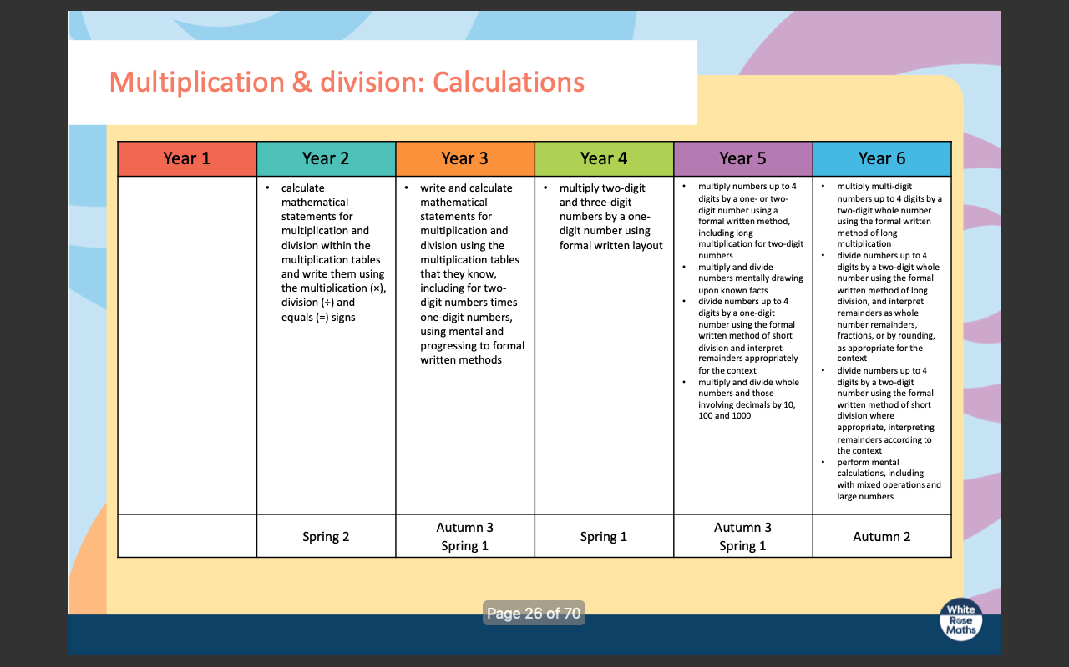
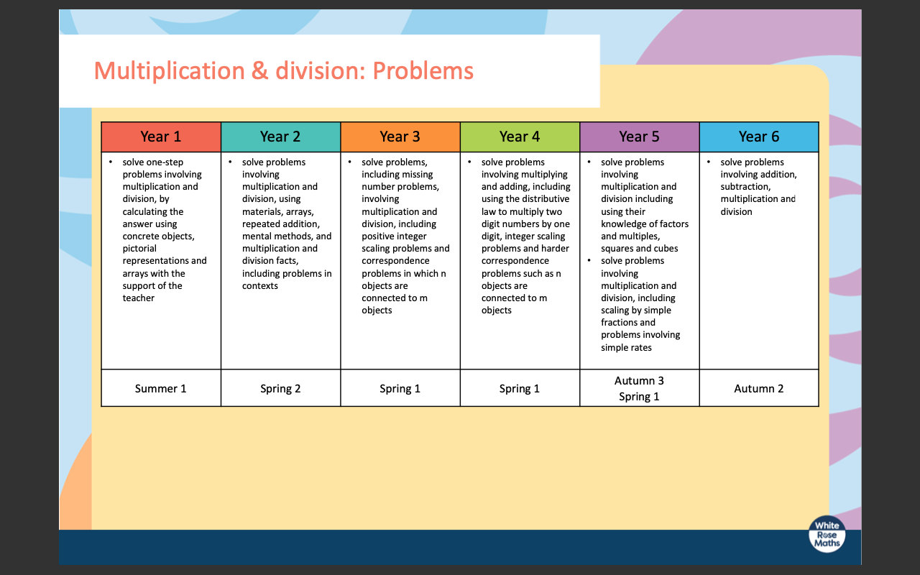
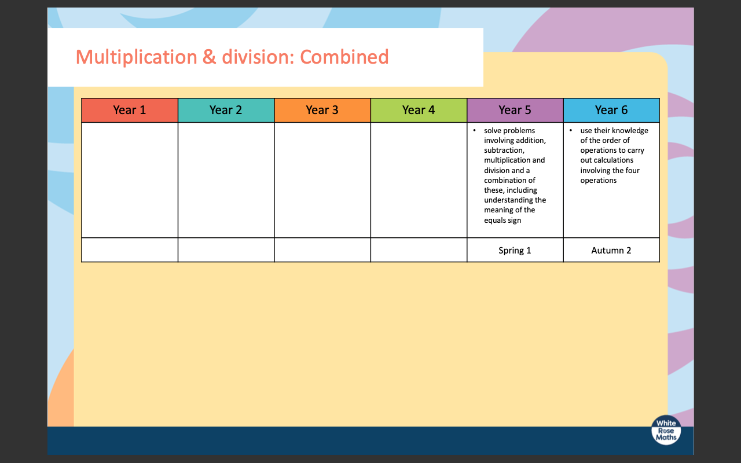
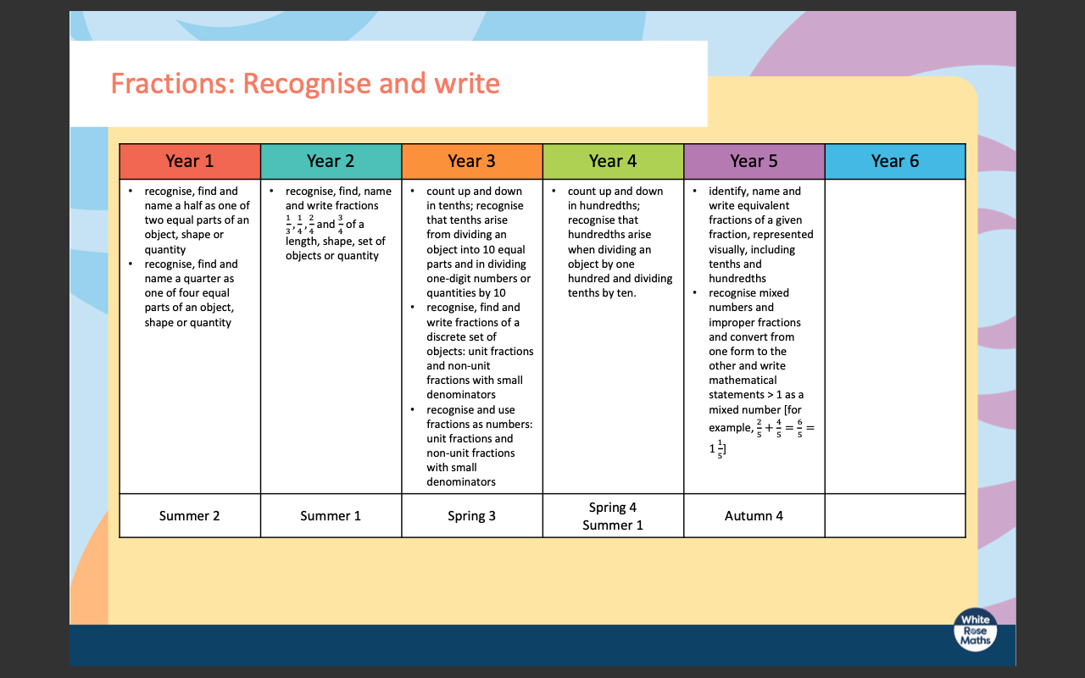
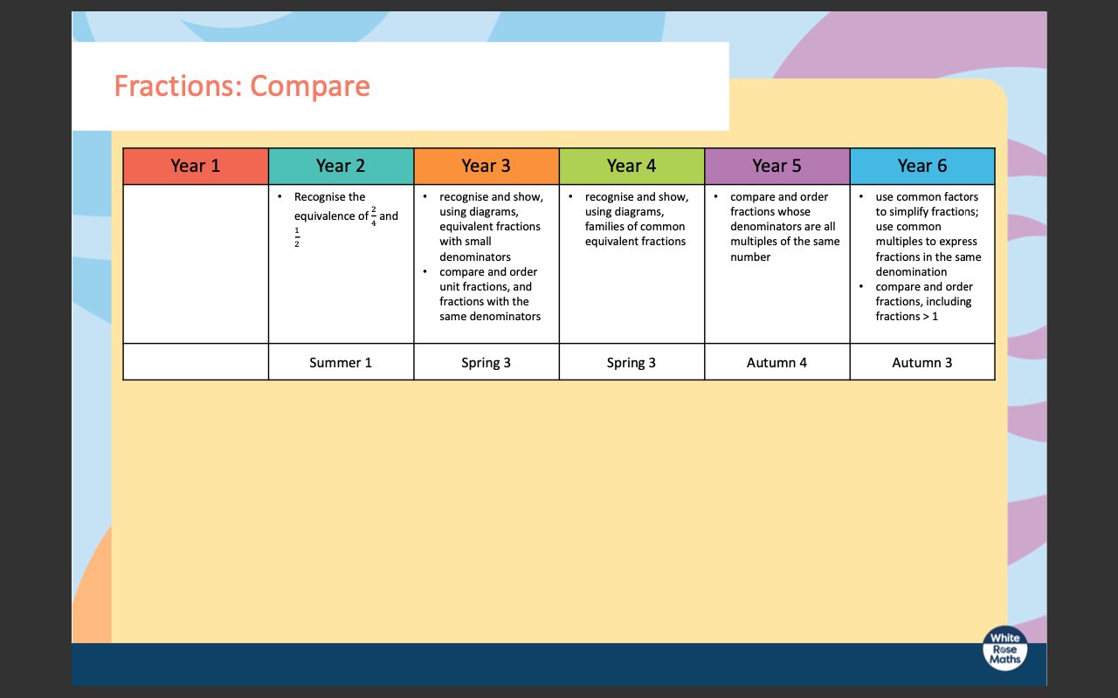
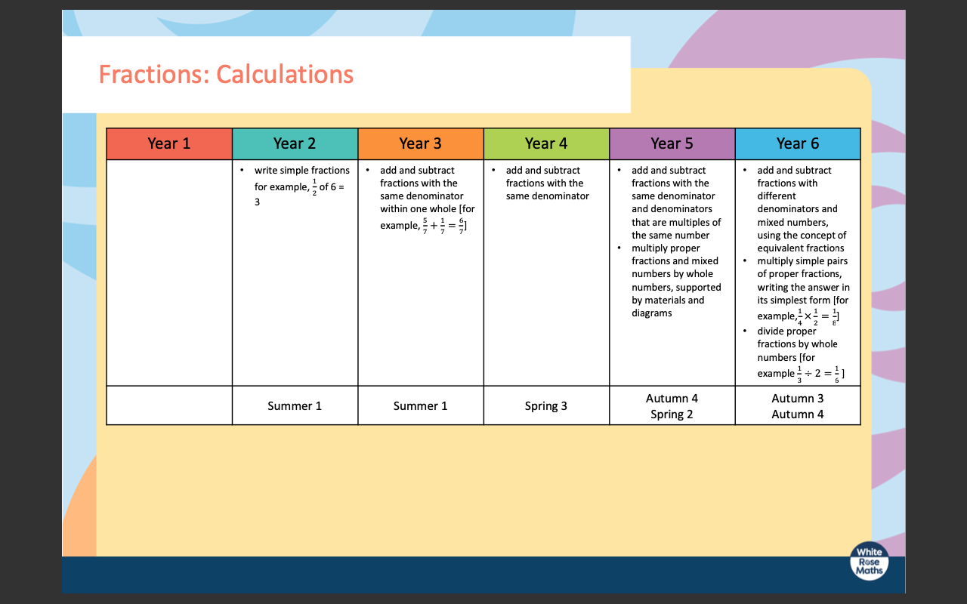
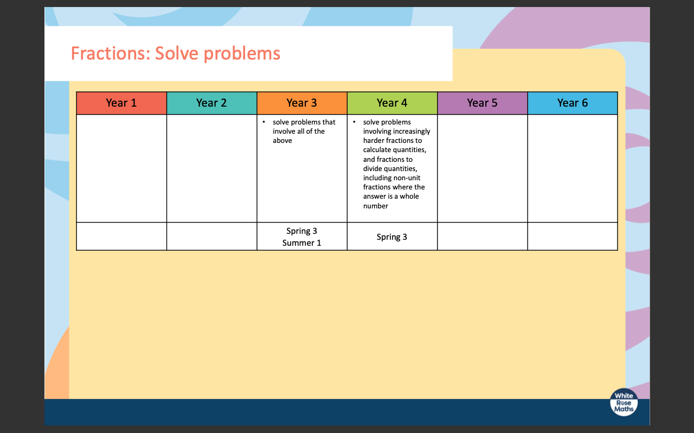
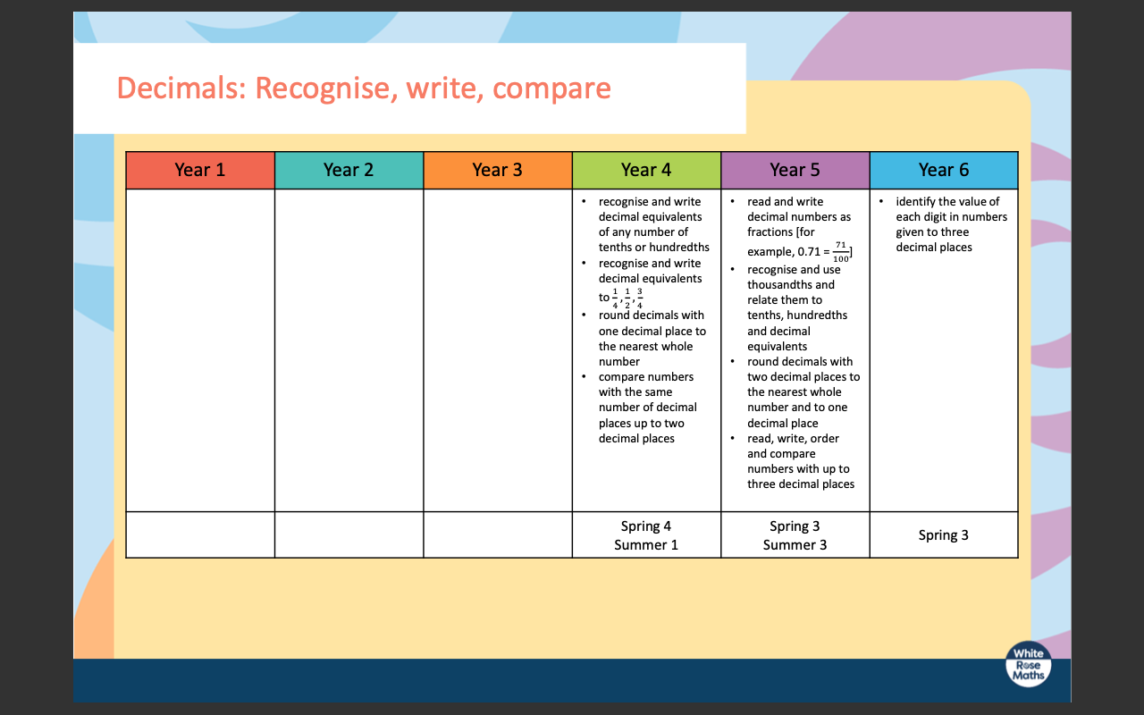
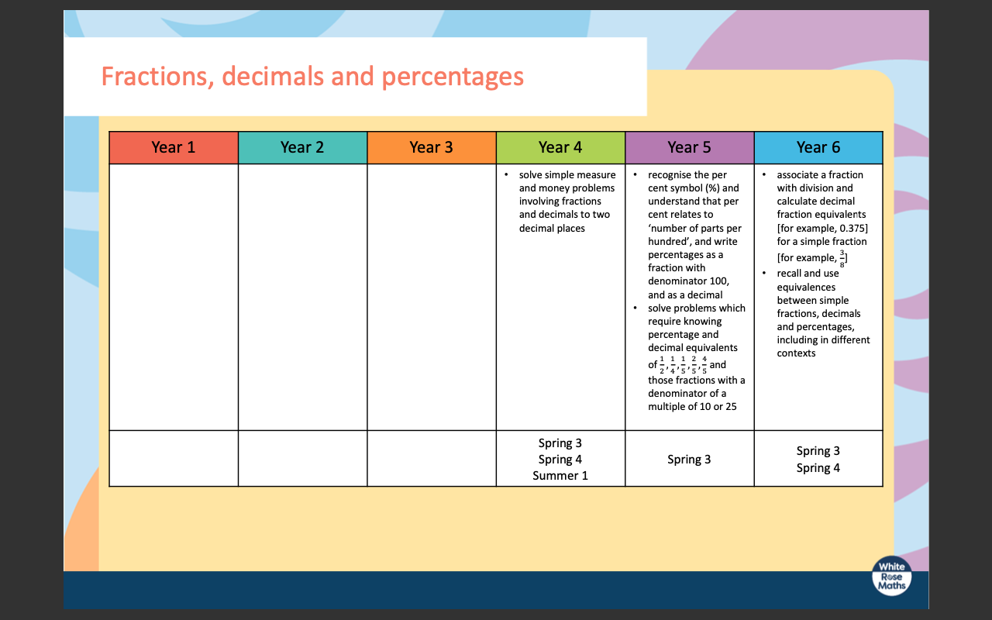
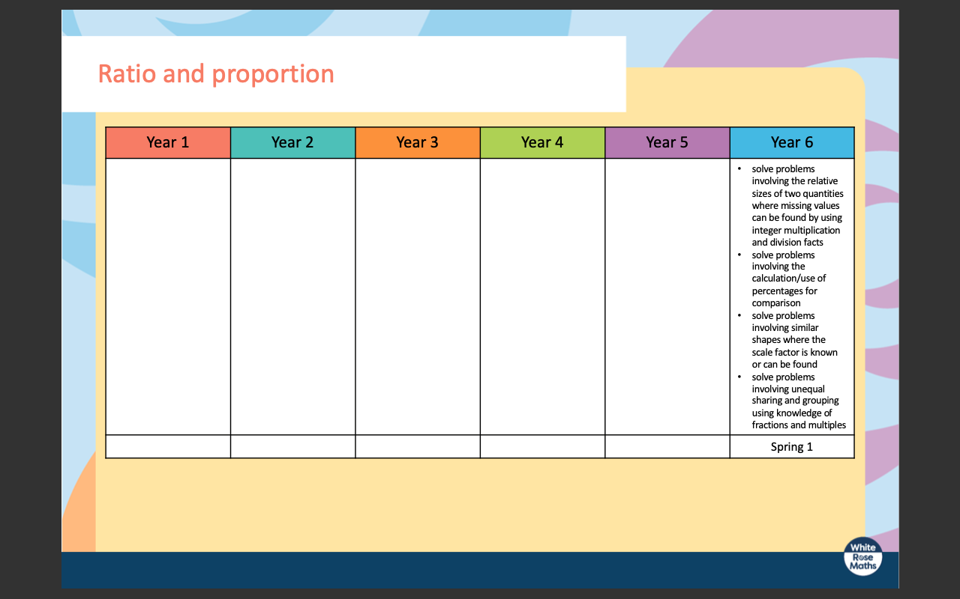
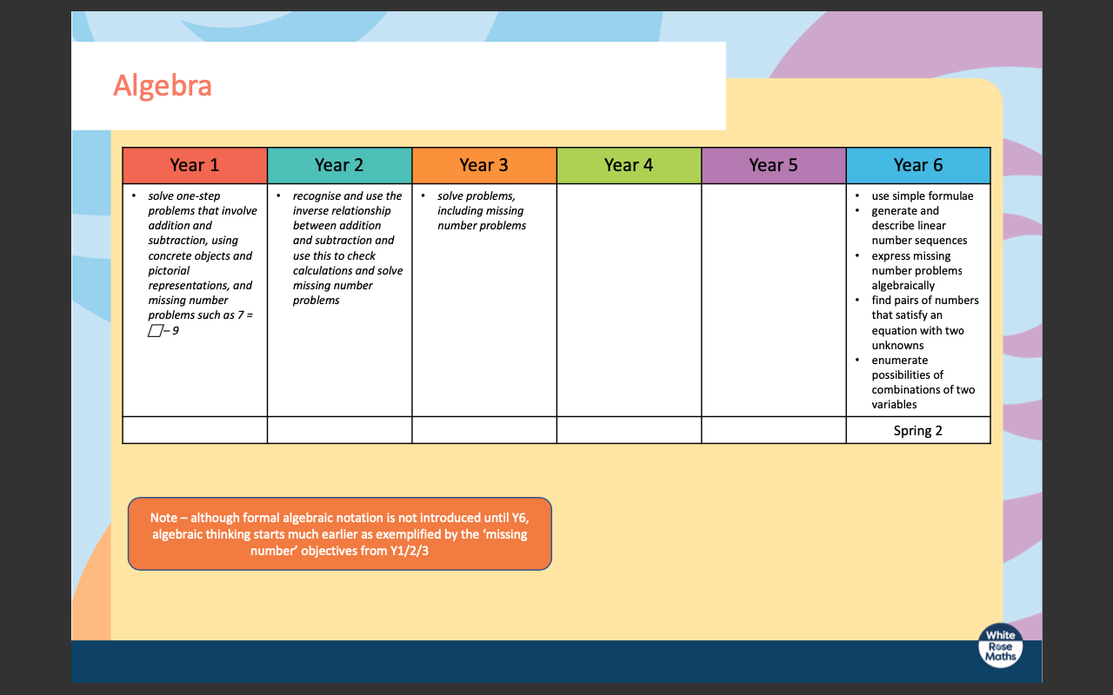
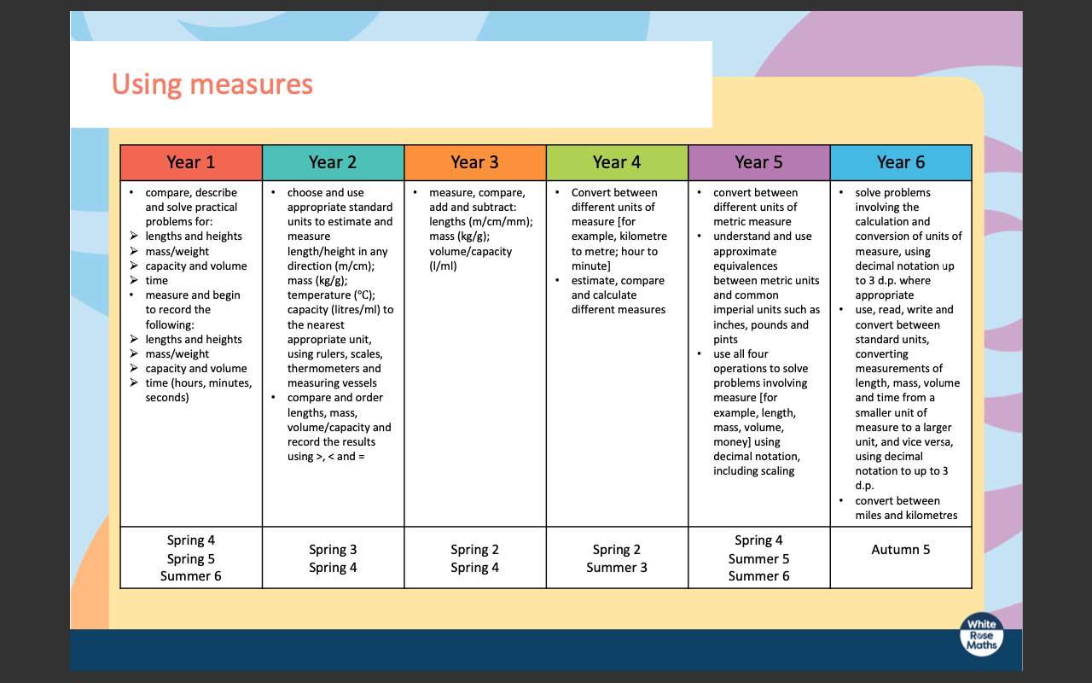
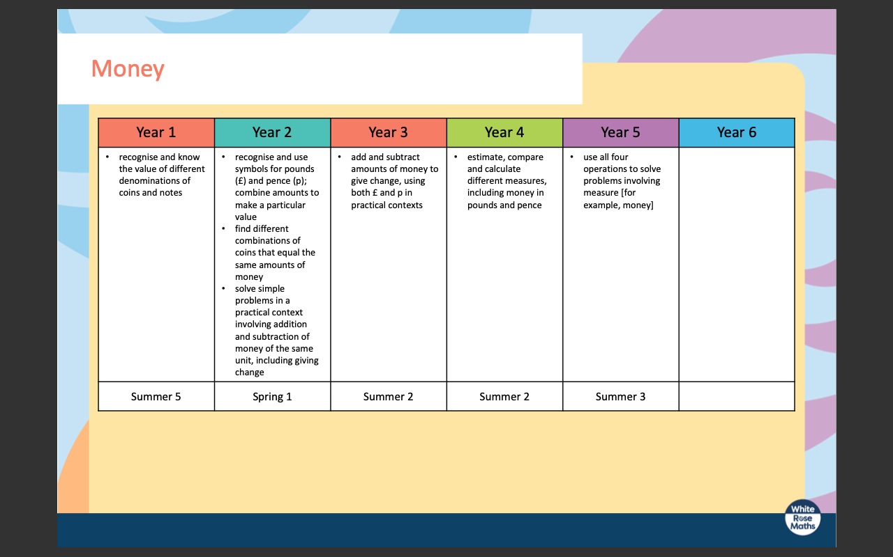
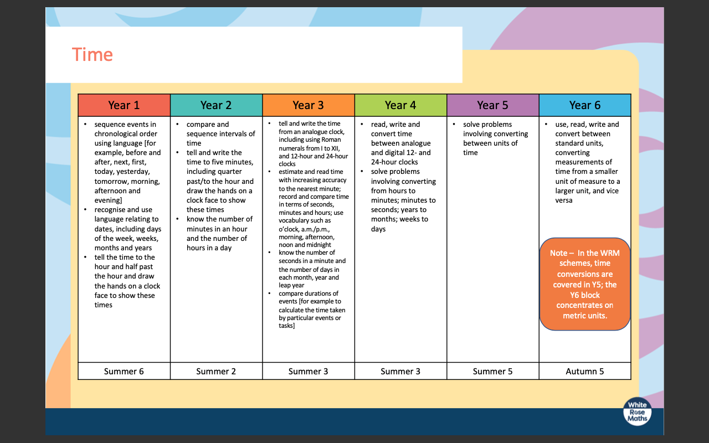
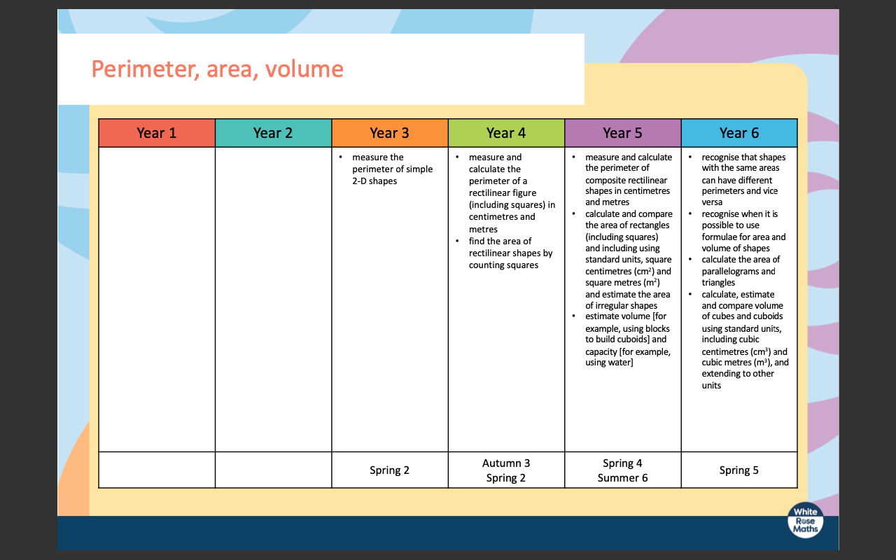
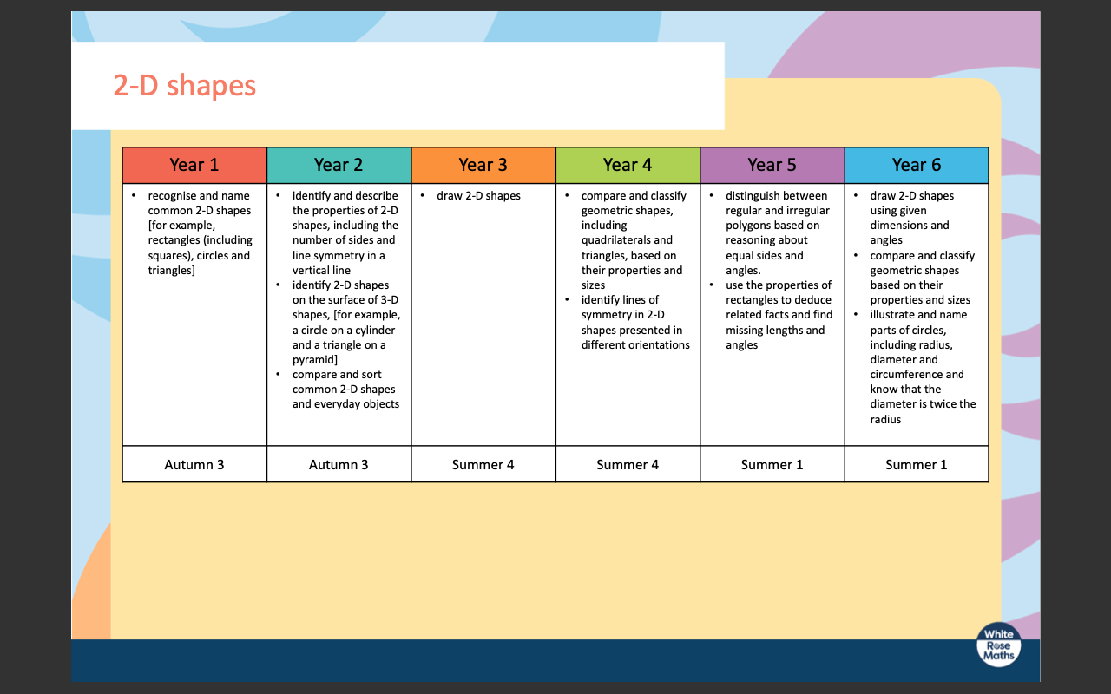
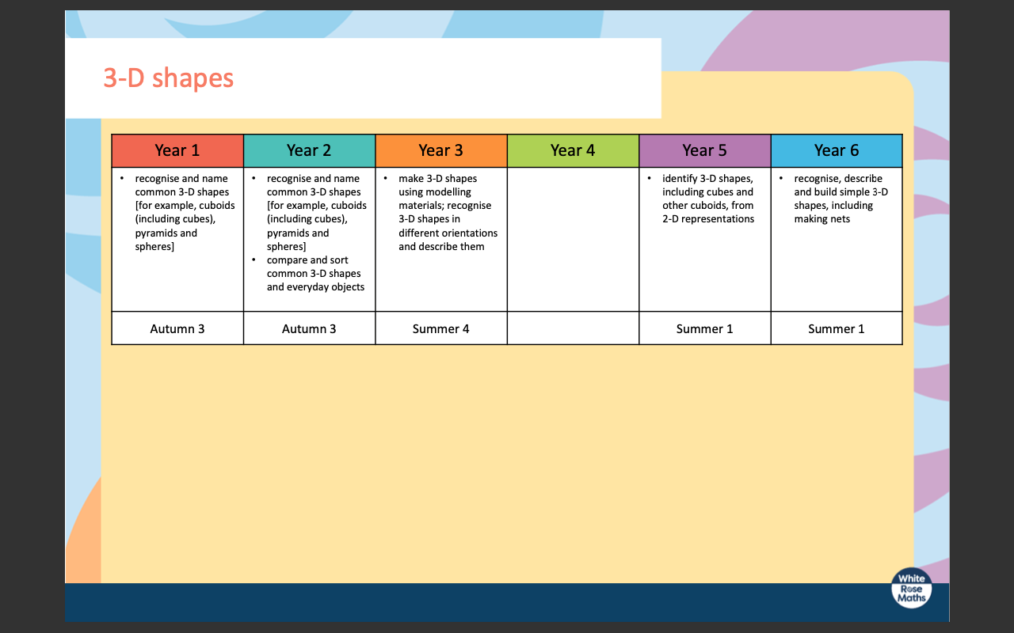
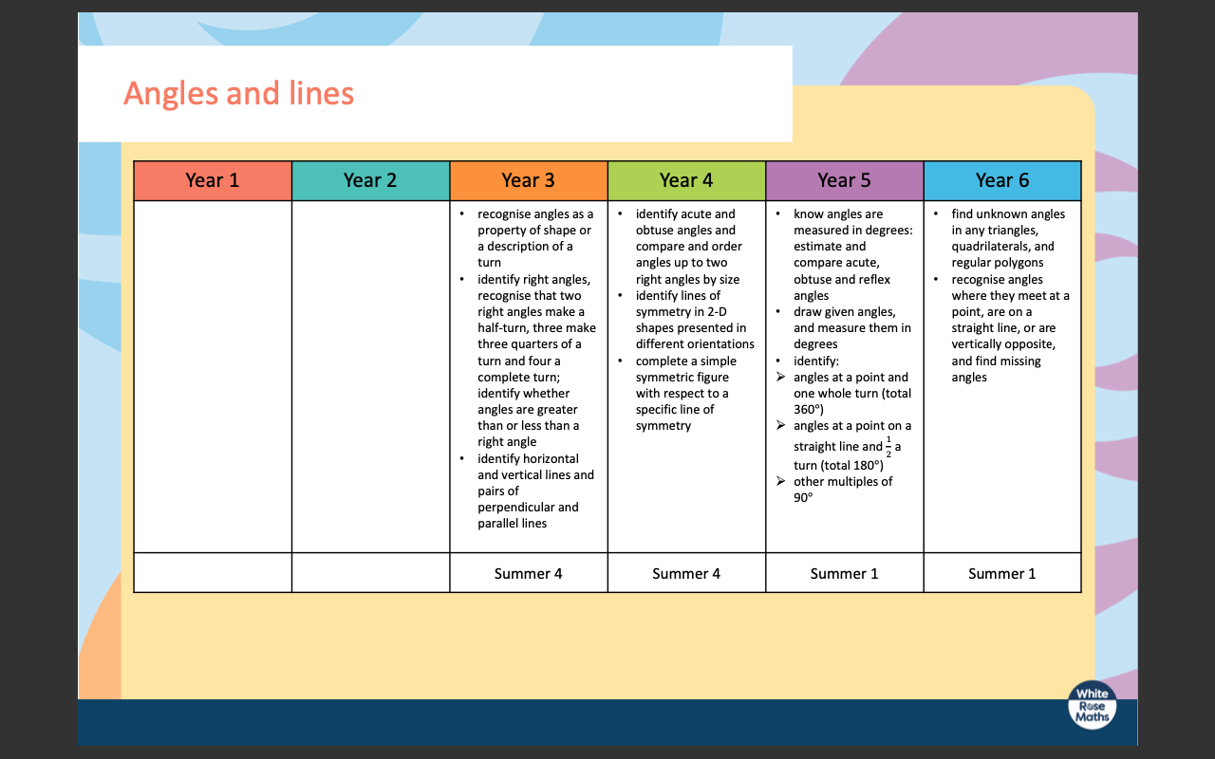
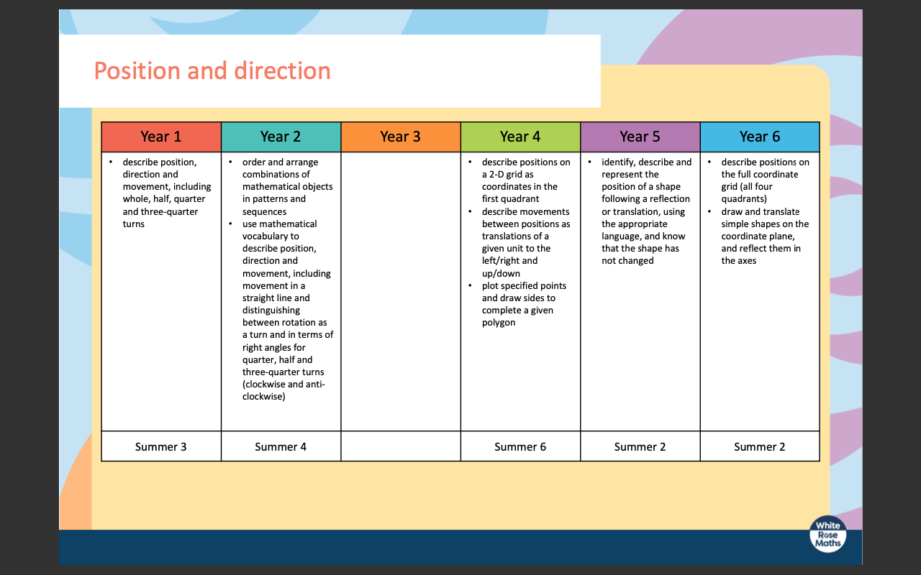
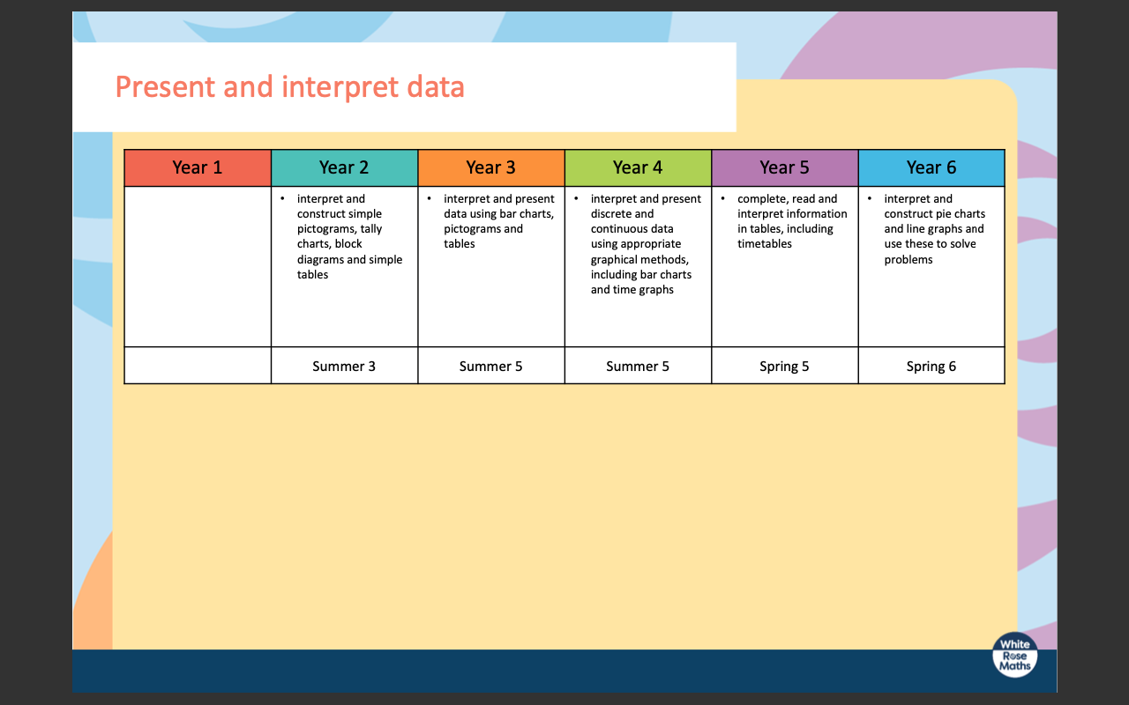
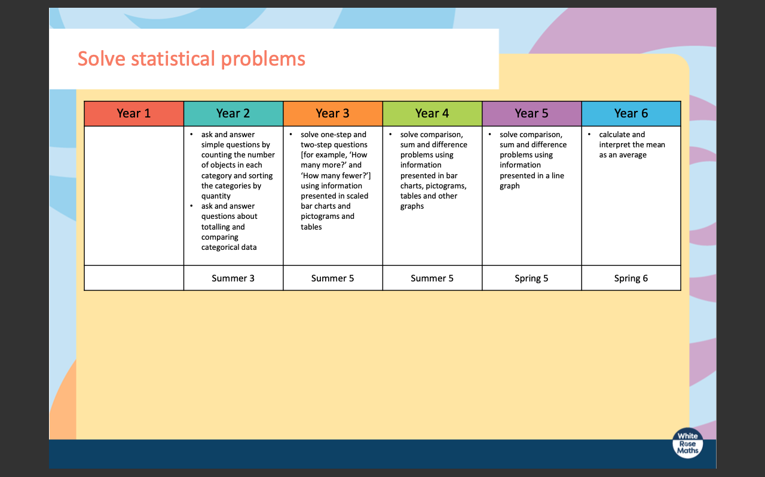

Planning Examples
Maths

