Programme of Study: EYFS – Oak (Reception)

 | Autumn Term |  | Spring Term |  | Summer Term
 | Part 1 | Part 2 | Part 1 | Part 2 | Part 1 | Part 2
Termly Theme | Marvellous me! | Peek into the past | Around the world | Once upon a time… | New Life | Outdoor adventures
Focus Topics and Lines of Enquiry | Starting school  My new class  Relationships  Me & my family  Seasons: Autumn | Bonfire night  Colour  Diwali  Light and Dark  Christmas  Seasons: Autumn / Winter | Winter  Polar regions  Hot and Cold Climates Contrasting environments Chinese New Year  Seasons: Winter | Traditional tales  Journeys  Homes  Castles  Seasons: Spring | New Life – Plants & Animals  Growing  Life cycles  Healthy eating  Seasons: Spring / Summer | Seasides  Underwater worlds Seasons: Summer
Literacy Core Texts | You Choose  by Nick Sharratt  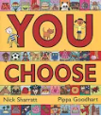  Shark in the Park on a Windy Day by Nick Sharratt  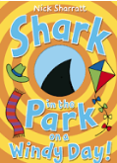  We’re Going on a Leaf Hunt by Steve Metzger  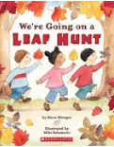  We’re going on a bear hunt  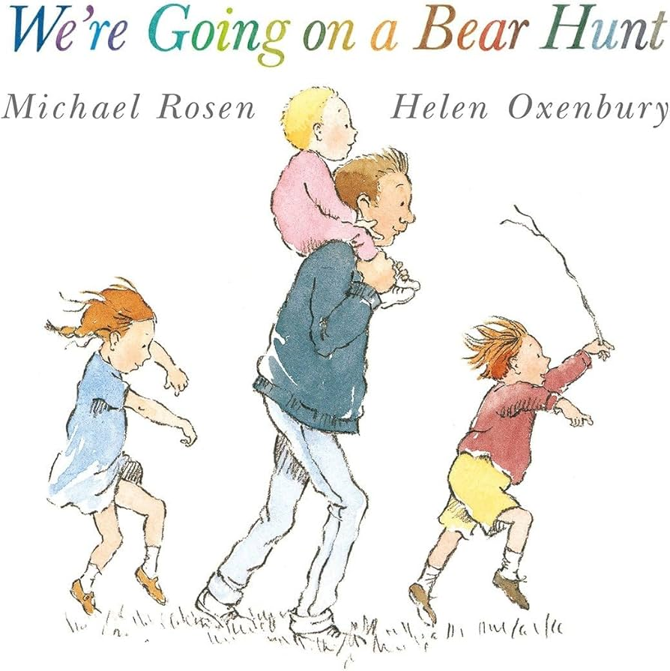 | Sparks in the Sky  by Twinkl Originals  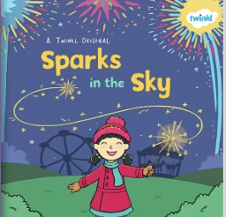  Chapatti Moon  by Pippa Goodhart  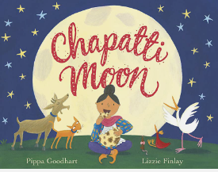  Star in the Jar  by Sam Hay  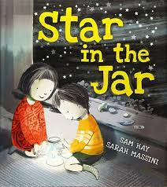  Stickman  by Julia Donaldson  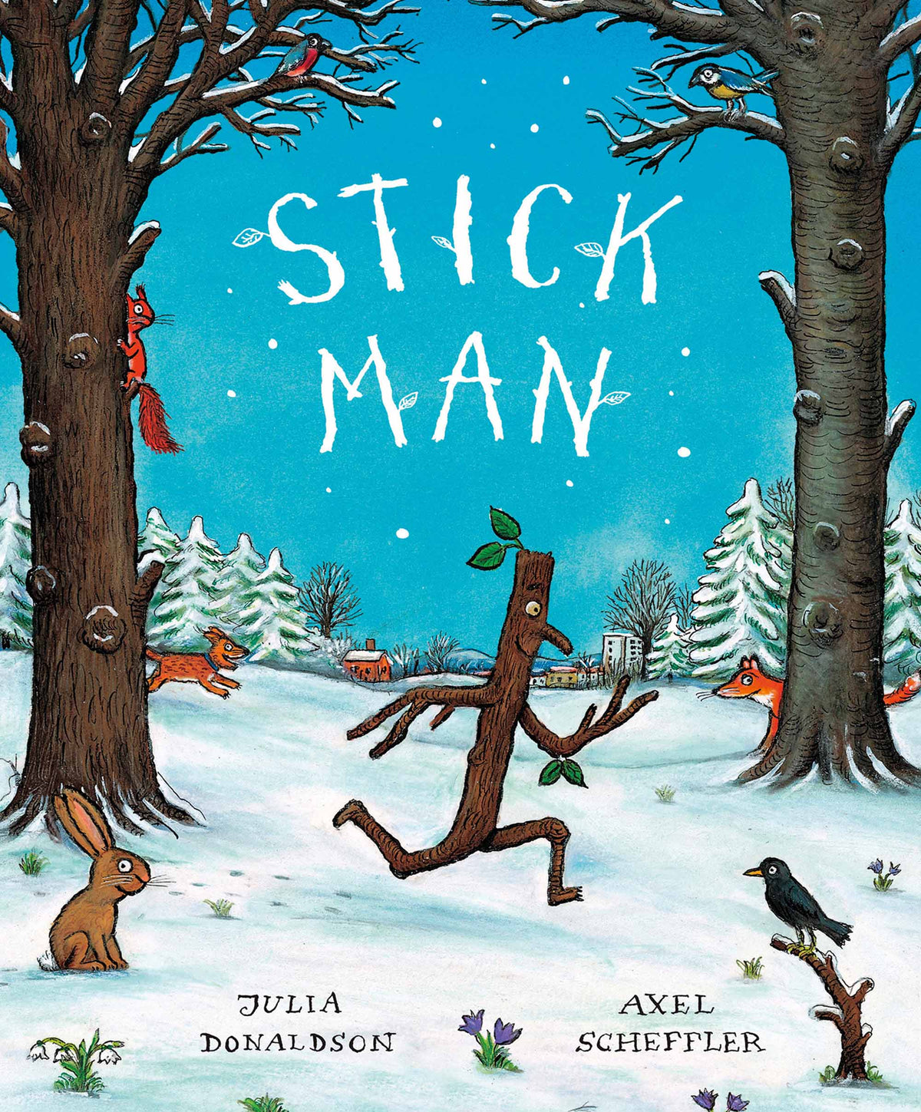 | One Snowy Night  by Nick Butterworth  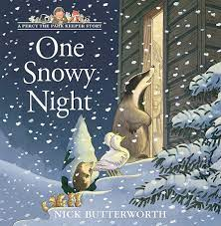  Jack Frost  by Kazuna Kohora  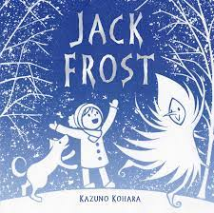  Monkey Puzzle  by Julia Donaldson  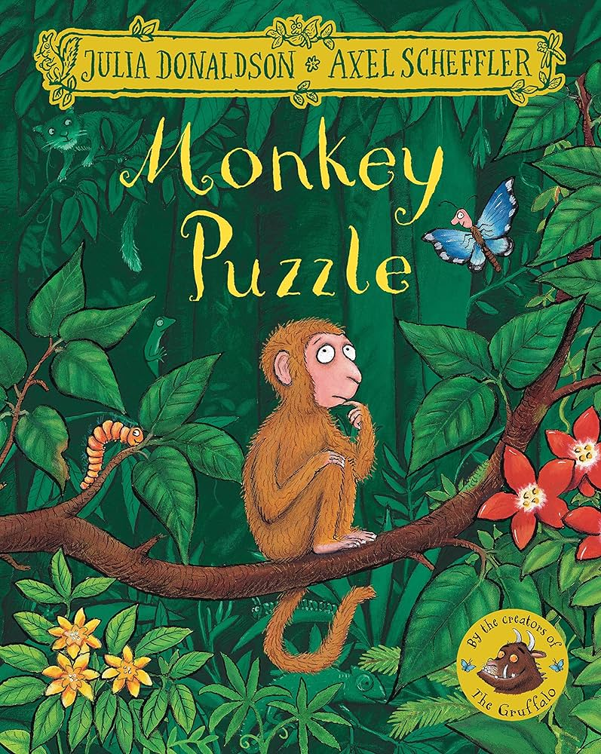 | Little Red Riding Hood  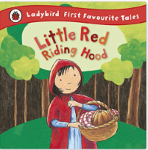  The Three Little Pigs  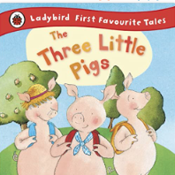  Jack and the Beanstalk  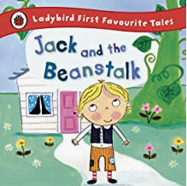 | The Great Goat Chase by Tony Bonning  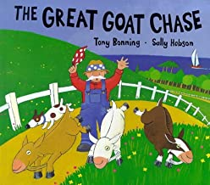  What the Ladybird Heard by Julia Donaldson  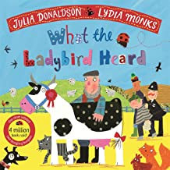  From tadpole to frog and other non-fiction texts  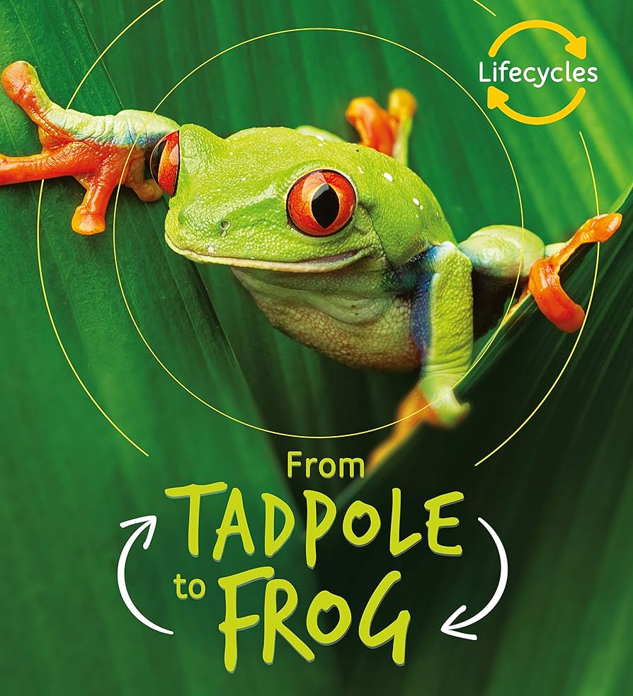 | Tiddler by Julia Donaldson 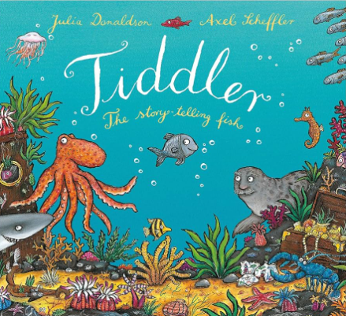  Billy’s Bucket  by Nick Sharratt  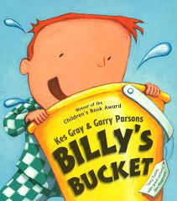  Superworm  by Julia Donaldson  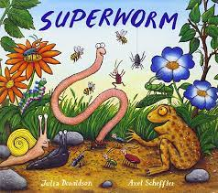  Commotion in the Ocean by Giles Andrae  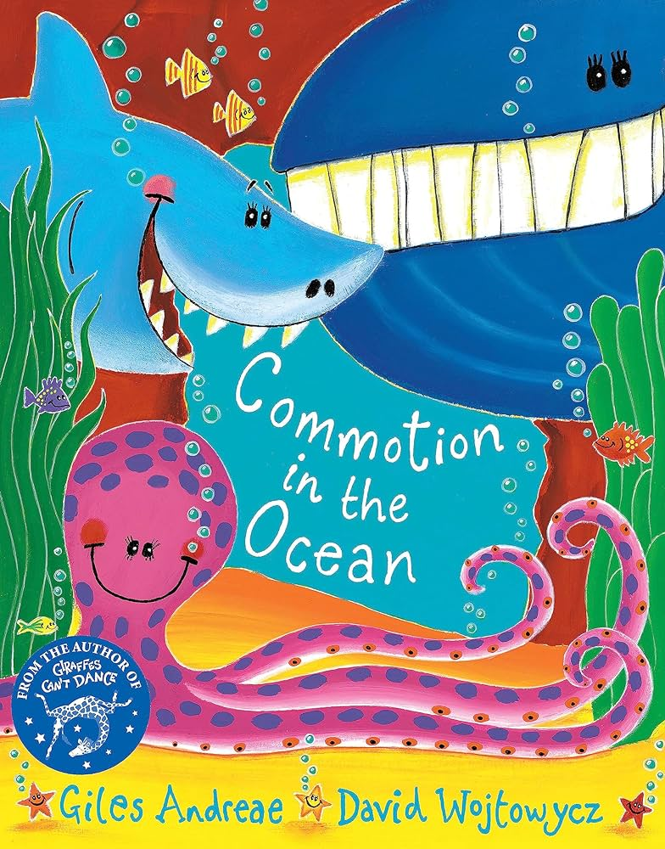
Supplementary Texts  Active Shared Reading selected texts | Fiction  The Same But Different Too  The Colour Monster  The Tiger who came to Tea  Non-Fiction  All about families  Autumn Info Book  Poetry  Nursery Rhymes  Autumn themed rhymes  The Hedgehog Song (YouTube)  Autumn Leave are falling down (To the tune of London Bridge)  Dingle Dangle Scarecrow  Five Little Leaves  Five Little Conkers | Fiction  Room on a Broom  Elmer  How to catch a Star  Can’t you sleep Little Bear?  Owl Babies  Stories linked to Christmas  Non-Fiction  Bonfire Night  Diwali  Christmas  Poetry  Nursery rhymes  Christmas songs/rhymes | Fiction  The Snowflake  Sneezy the Snowman  Poles Apart  Little Polar Bear  How to ride a Polar Bear  The Snail and the Whale  Non-Fiction  Winter Info Book Penguins/Polar Bears (National Geographic Kids)  Poetry  Action rhymes Poems linked to Winter | Fiction  Goldilocks and the Three Bears  Billy Goats Gruff  other traditional tales…  Rapunzel  Hansel and Gretel  Sleeping Beauty  Snow White  Non-Fiction  Castles (Collins Big Cat)  Spring Info Book  Poetry  Grand Old Duke of York  Sing a Sing of Sixpence  Poems linked to Spring | Fiction  Hettie Peck  The Little Red Hen  Farmer Duck  The Pig in the Pond Handa’s Surprise  Doing the animal bop  The Very Hungry Caterpillar  Non-Fiction  Seed to a Plant (National Geographic Kids)  Poetry  Farm based Old MacDonald had a Farm  Baa Baa Black Sheep Goosey Goosey Gander  Farmyard Hulabaloo by Giles Andreae | Fiction  Pirates love underpants  Hooray for fish!  Sharing a Shell  The Singing Mermaid  Winnie at the Seaside  Winne under the Sea  Doug the Bug  The Giant Jam  Sandwich  Non-Fiction  Under the Sea by Anna Milbourne  Sea Turtles and Dolpins by National Geographical Kids  Poetry  Commotion in the Ocean by Giles Andrease
Literacy  Word Reading | Pink Band Books  Phase 2 GPCs including a heavy focus on oral blending and segmenting | Pink Band Books  Phase 2 GPCs including a heavy focus on oral blending and segmenting  Phase 2 tricky words: I/no/to/go/the/into | Red Band Books  Introduction of Phase 3 GPCs  Begin Phase 3 tricky words: he/she/we/be/me/ was/my/you/they | Red/Yellow Band Books  Continuation of Phase 3 GPCs  Continue Phase 3 tricky words: her, all, are  Begin Phase 4 tricky words:  like, said, when, have, one | Yellow Band Books  Continue and consolidate Phase 3 GPCs  Drip Phase 4 in Phase 3 to stretch and challenge  Continue Phase 4 tricky words: come, do, so, were, some, there, out, little, what | Yelllow/Blue Band Books  Phase 4 CCVC and CVCC blending and segmenting  Polysyllabic words containing Phase 2 and 3 graphemes with adjacent consonants  Consolidate Phase 4 tricky words
Literacy  Comprehension | Listens to and shows an interest in stories.  Talks about favourite stories to others.  Joins in with nursery rhymes. | Begins to retell familiar stories through acting and role play.  Sequences events in stories using vocabulary of beginning, middle and end. | Begins to make up and act out own stories in play (developed through small world, sand and water areas in CP). | Can anticipate key events and is beginning to make predictions. | Can explain the stories they have listened to using their own words.  Is beginning to understand that non-fiction is a non- story and gives information. | Can answer questions about what they have read and what has been read to them.
Literacy  Writing | Mark making  Pattern tracing  Representing name  Correct letter formation linked to phonics | Writing name  Correct letter formation linked to phonics  Writing CVC words  Writing tricky words | Writing CVC words  Applying Phase 3 GPCs to spelling including tricky words  Captions, lists and messages  Re-visit letter formations | Begin to hold and write a simple sentence.  Applying Phase 3 GPCs to spelling  Writing tricky words  Finger spacing and capital letter writing | Write a short sentence from memory.  Writing tricky words  Finger spacing  Begin to use a capital letter and full stop in a sentence. | Write sentences using a range of tricky words.  Use a full stop and capital letter in writing.  CCVC and CVCC word writing
Maths  Number and Numerical Patterns  (following WhiteRose) | Baseline  Match, sort and compare  Identifying a set  Talk about measure and patterns  Compare size, mass, capacity and continue simple patterns  It’s me, 1, 2, 3  Subitise, represent numbers, know one more and one less  Circles and triangles  Identify and compare shapes  1, 2, 3, 4, 5  Representing, comparing and composition of numbers  Shapes with 4 sides  Identify and compare squares and rectangles |  | Alive in 5  Subitise, represent and compare to 5  Mass and capacity  Measuring and comparing using correct vocabulary  Growing 6, 7, 8  Representing, comparing and composition of numbers  Length, height and time  Measuring and comparing using correct vocabulary  Building 9 and 10  Representing, comparing and composition of numbers 9 and 10, number bonds to 10  Explore 3D shapes  Identify and compare 3D shapes |  | To 20 and beyond  Counting forwards and backwards from 20  How many now?  Building and counting numbers beyond 10, adding more, taking away  Manipulate, compose and decompose  Spatial reasoning  Sharing and grouping  Odd and evens, doubling  Visualise, build and map  Describe positions and explore mapping  Make connections  Deepen understanding and see patterns and relationships  Consolidation
Understanding the World  People and Communities  (RE & Geography links)   | Talking about themselves, their home and their family members.  Different kinds of families and the jobs people do in our community  Harvest festival | Bonfire Night including keeping safe  Diwali  Christmas | Around the World  The Arctic  Local habitat and contrasting country – Exploring China and Chinese New Year | Homes  Mother’s Day  Easter traditions | Exploring Maps  Farms  Maps linked to ‘What the Ladybird heard’ | Outdoor Adventurer  Seaside places – similarities and differences with local environment  Father’s Day
Religious Education Questful RE Units | EYFS 2 Harvest: Why do people of faith say thank you to God at Harvest time? (3)  EYFS 10 Prayer: What is prayer? (3)  Islam Judaism  EYFS 4 Christmas: How do Christians celebrate Jesus’ birthday? (4+2)  Why do Hindus light candles at Diwali? Hinduism |  | EYFS 9 Special Places: What makes a place Holy? (5)  Hinduism Islam Judaism  EYFS 6: Stories Jesus told (3)  EYFS 7 Easter: Why do Christians believe that Easter is all about love? (3) |  | EYFS 11 Special Times: How do you celebrate special times? (5) Hinduism Islam Judaism Sikhism  EYFS 3 Special People: Why do Christians believe that Jesus is special? (6)  Founders and Leaders of other faiths: Buddhism Islam Sikhism
Understanding the World  The Natural World  (Science links) | Ourselves – bodies and senses  Seasons – Autumn: changes, weather etc.  Hibernation | Colour around us  Light and dark  Sun, moon and space  Nocturnal animals | Seasons – Winter: changes, weather etc.  RSPB Bird Watch  Polar animals  Ice freezing and melting | Materials  Seasons – Spring: changes, weather etc.  New Life in nature | Farm animals  Life cycles  Planting and growing | Sea creatures  Floating and sinking  Minibeasts  Seasons – Summer: changes, weather etc.
Understanding the World  Past and Present  (History links) | Changes –from a baby to school  Birthdays | Peek into the Past  Bonfire Night – Guy Fawkes  Remembrance Sunday |  | Adventures through time  Castles |  | Seasides in the past
Understanding the World  (Computing links) | Computing through continuous provision | Using a computer | All about instructions | Exploring Hardware | Programming Bee-Bots | Introduction to Data
Expressive Arts and Design  Being Imaginative and Expressive  (Music links) | Exploring Sound  Regular singing – nursery rhymes, counting songs.  Role play – basic home corner set up  Create small worlds | Celebration Music  Diwali music and dance  Nativity performance  Role play – home corner enhancements linked to Christmas  Make imaginative and complex small worlds | Music and Movement  Winter songs  Chinese dragon dance  Small world – The Arctic  Role play – home corner enhancements shopping lists, messages | Musical Stories  Traditional tale songs  Small world – Traditional tale settings (Castles)  Role play – home corner enhancements  – playdough table to create own food | Transport  Small world – Farmyard settings  Role play – home corner enhancement – growing table – herbs, tomato plants, lettuce etc | Big Band  Seaside songs  Small world – Under the Sea (Pirates)  Role play – Seaside café/ ice cream shop
Creating with Materials  (Art and Design links) | Use of continuous provision and how to use the paint and workshop areas  Self-portraits  Painting – colour mixing Printing  Autumn pictures and paintings  Collaborative art: Andy Goldsworthy - Autumn Walk | Firework pictures Rocket models Painting - adding textures Kandinsky/Pollock/ Mondrian  Rangoli patterns Christmas crafts and decorations  Box Christmas tree for domestic area | Winter pictures and scenes - collage Jack Frost  Painting – making shades of a colour Cold colours Chinese new year lanterns  Dragon models | Drawing/painting/ making story characters Model homes  Castles  Spring pictures  Baking and decorating buns/biscuits – Red Riding Hood link | Farm pictures Observational flower/plant drawing using pastels and chalk Focus Artist – Van Gogh (Sunflowers) | Seaside pictures  Sea creature models Lighthouse model Seascape collage Minibeast paintings Webs – paper plates and wool  Focus Artist – Matisse (Snail)
Creating with Materials  (Art and Design links) | Drawing:  Marvellous marks  Autumn craft:  Nature wreaths | Painting and mixed media: Paint my world  Christmas craft:  Salt dough decorations | Sculpture and 3D:  Creation station  Winter craft  Threaded snowflakes | Craft and Design:  Let’s get crafty  Spring craft:  Petal mandala sun catchers | Easter craft:  Egg threading | Summer craft:  Salt painting
Physical Development  Gross Motor Skills | Lancashire PE Passport Fundamental Movement Skills | Lancashire PE Passport FMS: Space | Lancashire PE Passport FMS: Elmer | Lancashire PE Passport  FMS: Castles | Lancashire PE Passport FMS: Jack and the Beanstalk | Lancashire PE Passport  FMS: How to Catch a Star
Fine Motor Skills | To be able to hold a pencil effectively for fluent writing the children will have opportunities throughout continuous provision to develop muscle tone and strength. Finger gym, dough activities, using tools, threading, weaving, block play and other resources in the environment all contribute to children developing an effective tripod grip.
Personal, Social and Emotional development  Self-Regulation, Managing Self and Building Relationships  (PSHE link) | PSED principles underpin daily classroom practise. In addition to this there is a weekly lesson which ensures that all aspects of PSED are covered over the year. Observations and interactions are central to supporting children in their personal, social and emotional development.
 | Self-Regulation:  My Feelings | Building Relationships: Special Relationships | Managing Self:  Taking on Challenges | Self-Regulation:  Listening and following instructions | Building Relationships:  My Family and Friends | Managing Self:  My wellbeing
Enrichment Opportunities | Harvest Celebration  Autumn walk  We’re Going on a Bear Hunt Barrow Buddy event  Poetry Festival | Bikeability  Pantomime trip  Nativity  Breakfast with Santa  Christmas Experience  Stay and Play  Santa Dash | Church visit  Valentine’s Day  Barrow Buddy event  Poetry Festival | Easter egg hunt  Barrow Buddy event  Surprise Storytellers event  Easter Crafts  Mother’s Day Worship at Church | Visit to the farm  Grow, grow, grow – Planting activity  BarrowFest  Spring Crafts parent workshop  Poetry Festival | Class assembly  Teddy Bears Picnic  Barrow Buddy event  Sports Day  Art Explorers parent workshop

