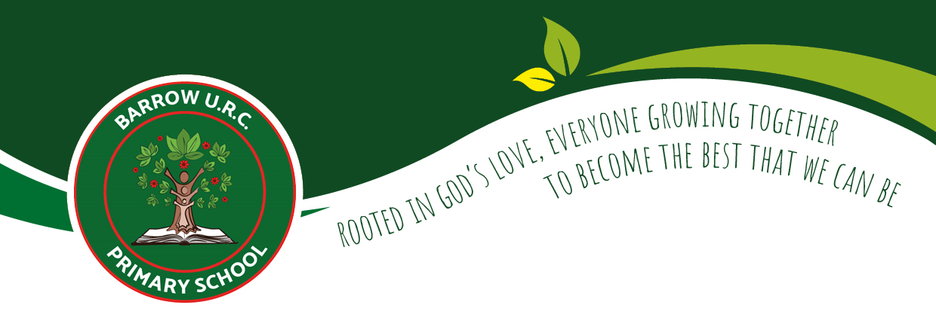

P.S.H.E. Curriculum Overview
2025/26
Subject Leader: Mrs Tate

Intent, Implementation
and Impact

Our Vision

Rooted in God’s love, we will grow and learn together through the delivery of an enriched and creative curriculum. We are passionately committed to developing happy, well-rounded children who can reach their full potential with the skills, knowledge, and experiences to achieve their dreams. Our Curriculum drivers help to drive and shape our curriculum and are incorporated across all subjects and themes. Our Drivers are:
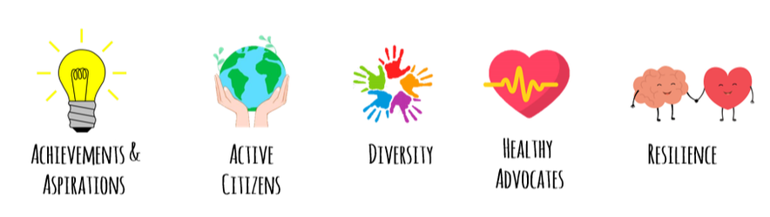
Intent

At Barrow URC Primary School, our intention is that when children leave, they will do so with the knowledge, understanding and emotions to be able to play an active, positive and successful role in today’s diverse society. We want our children to have high aspirations, a belief in themselves and realise that anything is possible if they put their mind to it. In an ever–changing world, it is important that they are aware, to an appropriate level, of different factors, which will affect their world, and that they learn how to deal with these, so that they have good mental health and well-being.

Our PSHE curriculum goes hand in hand with our School’s core values of Love, Respect, Kindness, Forgiveness, Honesty and Trust. We promote a nurturing and positive mind- set, developing learning and resulting in the acquisition of knowledge and skills, which will enable children to access the wider curriculum. We aim to prepare them to be responsible global citizens with an awareness of their place in the wider global community. We promote the spiritual, moral, cultural, mental and physical development of pupils, preparing them for the opportunities, responsibilities and experiences for later life. Our Relationships and Sex Education enables our children to learn how to be safe, and to understand and develop healthy relationships, both now and in their future lives

Implementation

We will use the following approaches in our teaching of PSHE:
- Our curriculum is delivered to the children through six units of work, each unit lasting one half term via the scheme of learning KAPOW.
- PSHCE is taught in one forty-five-minute slot once every fortnight.
- Revisiting the same units of work each year allows children to recall and build upon previous learning.
- During each lesson the children will explore underlying principles of PSHE education in depth.
- Each lesson will give the children opportunities to have deep and meaningful discussions, suitable and appropriate for the age and stage of the child.
- Children are able to have rich experiences within school through enrichment sessions and theme weeks.
- To ensure high levels of teaching our curriculum can be tailored to the meet the needs of the children, e.g. talking about a specific topic during PSHE lessons which might be having an impact within the class at that time.
- Our curriculum allows children to stay healthy, safe and feel prepared for life after Barrow.

Impact

We will assess the impact of the curriculum by:
- Pupil discussions about their learning – pupil voice interviews.
- Children will be able to confidently and clearly articulate their thoughts, feelings and opinions (during class or outside of class).
- Recapping topics will allow children to refer back to prior learning and use their sticky knowledge.
- Children will use a range of vocabulary.
- Children will be inspired to follow future careers related, eg. We are conservationist, We are geologists.
- In class there will be a calming, open, respectful and trustworthy environment where children feel they know who to speak to and how to speak to them.

Whole School Programme of Study:
P.S.H.E.

P.S.H.E. – Whole School Programme of Study (2024/25)

PSHE – Whole School Programme of Study (2025/26)

PSHE | Autumn | Spring | Summer
EYFS | - Self-regulation: My feelings (6)  - Building relationships: Special relationships (6) | - Managing self: Taking on challenges (6)  - Self-regulation: Listening and following instructions (6) | - Building relationships: My family and friends (6)  - Managing self: My wellbeing (6)
Year 1 | - Introduction: Setting ground rules for RSE & PSHE (1)  - Families and relationships (7)  - Health and wellbeing (8) | - Health and wellbeing (continued)  - Safety and the changing body (8) | - Citizenship (6)  - Economic wellbeing (6)  - & Transition lesson (1)
Year 2 | - Introduction: Setting ground rules for RSE & PSHE (1)  - Families and relationships (7)  - Health and wellbeing (7) | - Health and wellbeing (continued)  - Safety and the changing body (9) | - Citizenship (7)  - Economic wellbeing (6)  - & Transition lesson (1)
Year 3 | - Introduction: Setting ground rules for RSE & PSHE (1)  - Families and relationships (8)  - Health and wellbeing (7) | - Health and wellbeing (continued)  - Safety and the changing body (8) | - Citizenship (7)  - Economic wellbeing (6)  - & Transition lesson (1)
Year 4 | - Introduction: Setting ground rules for RSE & PSHE (1)  - Families and relationships (8)  - Health and wellbeing (7) | - Health and wellbeing (continued)  - Safety and the changing body (8) | - Citizenship (6)  - Economic wellbeing (6)  - & Transition lesson (1)
Year 5 | - Introduction: Setting ground rules for RSE & PSHE (1)  - Families and relationships (8)  - Health and wellbeing (7) | - Health and wellbeing (7)  - Safety and the changing body (7) | - Citizenship (6)  - Economic wellbeing (6)  - & Transition lesson
Year 6 | - Introduction: Setting ground rules for RSE & PSHE (1)  - Families and relationships (6)  - Health and wellbeing (8) | - Health and wellbeing (continued)  - Safety and the changing body (8) | - Citizenship (6)  - Economic wellbeing (6)  - Identity (2)  - & Transition lesson (1)

P.S.H.E. in EYFS

In EYFS, PSHE is woven throughout the curriculum and taught through adult led activities and continuous provision. As well as following the KAPOW half termly units, teachers are able to integrate and weave key life skills throughout the children’s daily routines; in order for the children to reach the early learning goals. PSHE (although can be linked throughout the EYFS curriculum) lends itself to four particular areas, these are: personal, social and emotional development, communication and language, physical development and understanding of the world. Children are given opportunities to discuss and explore a variety of topics within all of these areas and through these discussions and hands on experiences children are able to develop strong self-awareness, manage their own feelings and behaviours, as well as, make relationships. Overall, this creates the foundation for children to build upon throughout KS1 and KS2.

P.S.H.E. and SEND Provision

The P.S.H.E. curriculum is planned and delivered to accommodate and challenge pupils of all abilities and address a range of learning needs. Teachers of P.S.H.C.E. will consider any additional needs of SEND pupils and will implement any relevant targets and support strategies as outlined on pupils’ Individual Education Plans. Where necessary, we will provide specialist equipment, adapt room layouts, utilise adult support and allow additional time for tasks, according to the needs of our pupils.

